**1:- Raw Rock crystal salt De-ice salt**

**ممكن صوره سياره كاسحه للجليد**

**We able to produce and supply over 2 million ton per years , we able enter any tender for salt around the globe , we looking for reduce invoice of cleaning roads from the snow by supply super quality salt making roads very safe , with best prices on time without any delay .**

De-icing Salt (Sodium chloride) is the most widely used de-icing agent in Europe , canada and usa and throughout the world due to its huge advantages over the alternatives.  
  
It is the ideal de-icing material because:  
It melts ice & snow rapidly.  
It is widely-occurring and readily available  
It is the most cheapest method as de-icer  
It is much efficient, easy to use, easy to spread, store and handle  
It is harmless to skin, clothing and environment

analysis as following , NacL OVER 98.59% ( purity) , Moisture 0.42 % and Water Insoluble 0.46 % ,

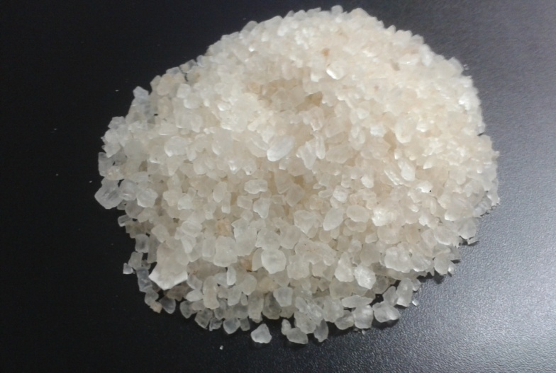

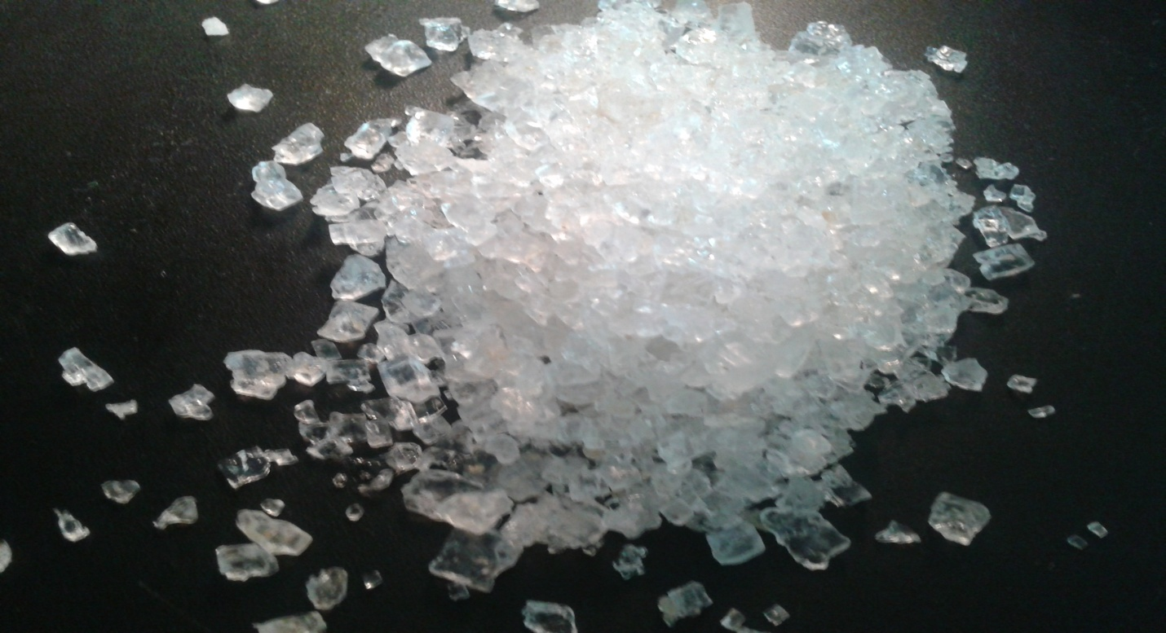

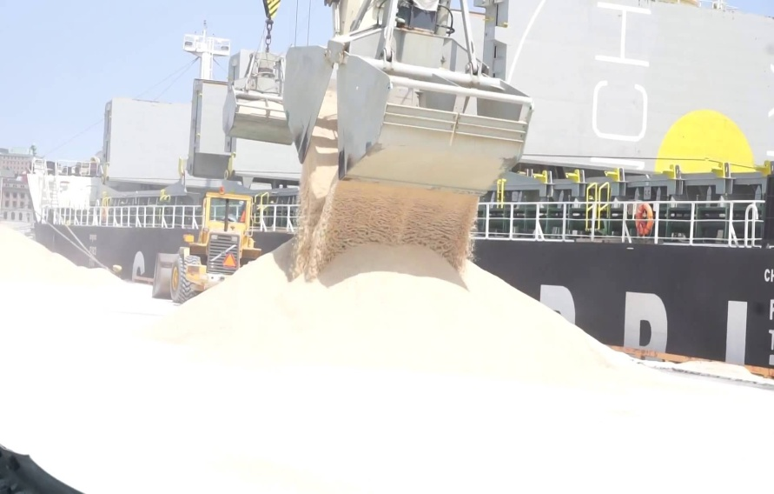

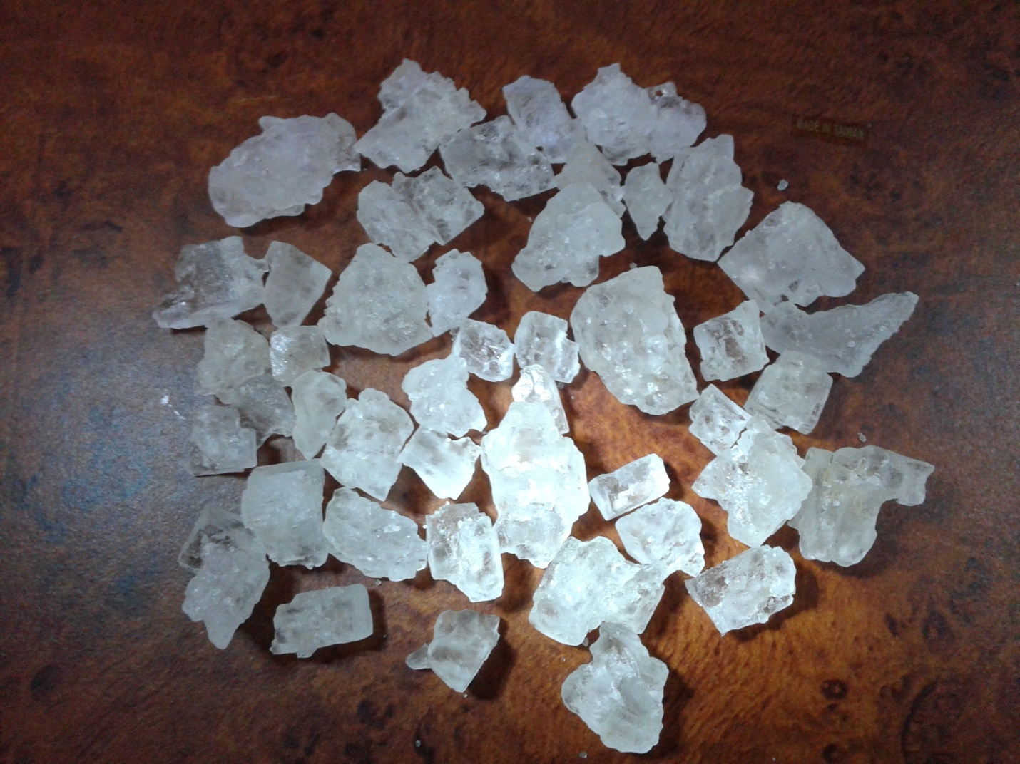

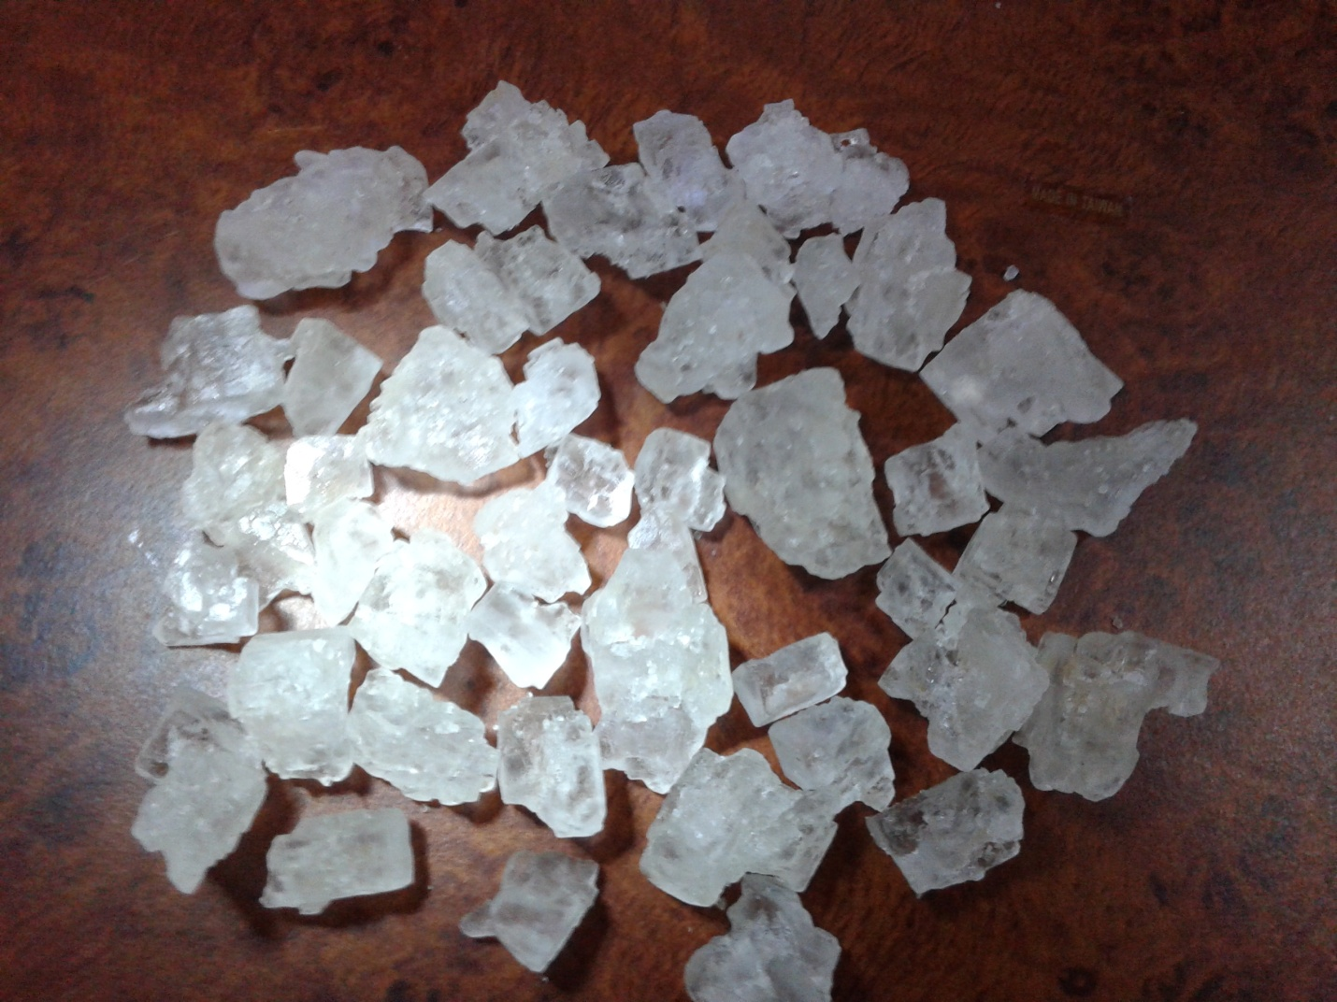

| SGS ANALYSIS AS RAW SALT ROCK CRYSTAL SALT  **Elements** | **Result %** | **Analysis Method** |
| --- | --- | --- |
| Moisture | 0.42 | ASTM E534/2003 |
| Purity (as Sodium Chloride) | 98.59 |
| Water Insoluble | 0.46 |
| SO4 | 0.60 |
| Ca++ | 0.18 |
| Mg++ | 0.05 |
| CaSO4 | 0.61 |
| MgSO4 | 0.21 |
| Mgcl2 | 0.03 |

2:- raw sea salt for de-ice

We able to supply high quality sea salt too for de-ice Nacl min 97.5% and moisture from 1-4 % max

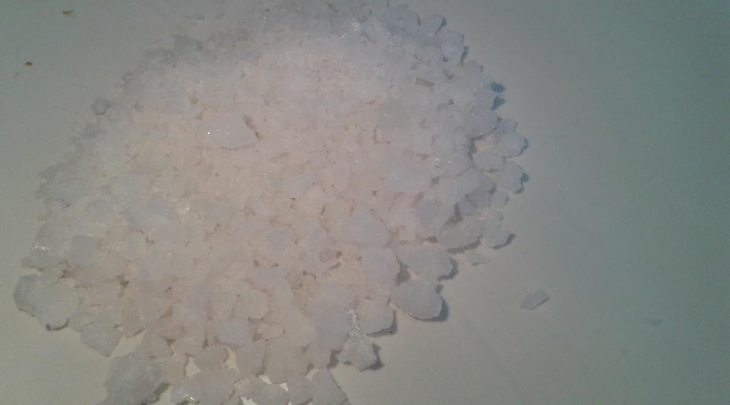

* Sorting , crush high level and sizing according to client want ( 0-4 &1-5 &2-10 &1-12) mm or any size we do it and we can supply it raw without crushing according to your request.
* Anti caking agent as client request 50 ppm or any percent client want and the kind the client want for anti caking.
* We give SGS certification , by analysis and quantity load on the vessel , and can check vessel banker too before loading to arrive salt in quality vessel too .

**condition of sales**

Minimum Order Quantity: 3000 metric tons

Shipment: in bulk

Our loading vessel rate best rate for loading vessel in Egypt without any delay

Origin: Egypt

Delivery terms: EXW , FOB , CIF OR EVEN DDP to the warehouse of our client , incomers 2010

Packing options bags 50k.g , or bags 25 k.g or jumbo bags 1 ton or 1.5 ton in bags min order 200 ton

